Palmerston North Dance Association Inc. 
Restricted Ballet & Modern Competition Syllabus
Open Groups, duos & trios
NYPA Nomination in Ballet & Group/Troupe

Friday 27th - Sunday 29th March 2026
Venue:
Regent Theatre on Broadway
Palmerston North

Online Entries Link for solos/duos/trios will be posted on Facebook and website (pnda.nz)
22nd February 2026
after alert notices to opening date and specific time. Separate online entry form link will be posted on Facebook and website (pnda.nz) for Group/Troupes entries on
22nd February 2026
Entries close when we reach capacity or 24th February 2026
Entries limited to time available.

Adjudicator: Sonia Hems

Restricted classes are for those who have never been awarded first place in a similar class in any competition festival.
All group/troupe, duo & trio classes are open.
Nominations for PACANZ National Young Performer Award
Ballet and Troupes

Convenors
Maryanne Mechen’ Lauren Francis
pndacompetitions@gmail.com

CUP CONVENOR
All Cups are to be returned (clean) to the following address by 24th January 2026
PNDA, 440A Albert Street, Palmerston North, Email- pndacompetitions@gmail.com

ENTRY FEES

$6.00 Solo Entry $25.00 NYPA Nomination Classes Ballet & Troupes $8.00 Duo Entry $10.00 Group Entry (*please see below)
$9.00 Trio Entry $15.00 Compulsory admin fee.

*Teachers please note that if you enter more than five groups after 5 or more groups in the open section are entered the maximum amount to pay is $50. E.g. – 1 group $10, 2 groups $20, 3 groups $30, 4 groups $40, 5 groups $50 then $50 for 6-10 etc. up to 10 groups. Then classes are the standard $10 each.
This does not apply to NYPA Troupe/Group entries – this must be entered separately. If you are entering a NYPA Group, this cannot be entered into the open groups as well. NYPA Group/Troupe is $25 per group.

We will have an official videographer available to video your dances.
No unofficial videoing of dances please. Dance Studios may designate a
person to video their own NYPA nomination Troupe only, from a set area.

Rules and Instructions
- The PNDA competitions are strictly for Amateurs. An Amateur means one whose income is not derived from the exercise of his/her talents in which he/she is competing. Prize money won at this, or any similar competition festivals shall not affect the status of the Amateur.
- Entries close 24th February 2026 or when we reach capacity - whichever comes first.
- No Telephone entries. Full payment must accompany entry forms.
- Age as first day of competition.
- Proof of age may be requested by the Secretary to verify ANY competitors age on receipt of entry or at any time during the competition (regardless of placing)
- No competitor may compete out of his or her age group except in duo, trio, and group classes. The age of the oldest competitor in Troupes, duos or trios determines the age group class to enter – e.g. 13 years & under or 13 years and over if there are older members in the group. We can accept a limited number of 13 year olds in the younger group.
- Entry to watch from the auditorium is free for Children. Adults are $5 a session to enter the auditorium, $9 a day or $15 for a Weekend Pass. The venue may have additional costs. A support person for the competitor is welcome side stage and backstage if needed.
- Time limits for dances – 12 years and under – Up to 3 minutes
13 years and over – Up to 4 minutes
- Any competitor who leaves the stage is unable to receive a first, second or third placing. Only competitors under 12 years will be able to repeat their dance if time allows. Competitors will not be able to repeat their dance if they leave the stage during a championship class. The Stage Manager has discretion during any technical difficulties.
- Titles of Dances – the following dances MUST have titles on the entry form – Classical Barefoot, Demi Character, National Character in ALL age groups. All Variation classes must have titles.
11. Cups – the engraving of trophies, cups and shields or trays and the payment of the engraving are the responsibility of the cup winner. All costs due to the return of the cups to the PNDA Inc are the responsibility of the cup winner also. Cups returned after the cut-off date may incur a late penalty fee. Cups are to be engraved by a professional engraver. Parents/caregivers may be liable should any cups/trophies require repair, re-engraving or replacement.
12. Any complaints concerning the festival must be submitted in writing and received by the secretary of the Society within 12 hours of the subject of the complaint, accompanied by a $20 fee (refundable if complaint is upheld by the committee).
13. Sound system –Digital files used - The Association will provide a sound operator. You will be notified through Facebook as to the date to upload copies of your music in MP3 format.
(Please have a back-up – e.g., Phone, USB, or another device.
14. The Committee reserves the right to combine, divide or cancel classes and scholarship/championship entries according to entries received and will refund where applicable.
15. All competitors compete at their own risk.
16. No communication with the adjudicator is allowed during the competition.
17. Any competitor who has been taught by the adjudicator during the past two years is ineligible to enter.
18. THE ADJUDICATOR’S DECISION IS FINAL.

All Restricted Classes
 | Under 8 years |  | 12 & Under 14 years
01 | Classical Ballet | 16 | Classical Ballet (No Pointe)
 | (Zoe Holloway Trophy) |  | (Danceworks Trophy)
02 | Classical Barefoot | 17 | Classical Ballet (Pointe Only)
 | (Danceworks Trophy) |  | (Whitney Harrington Pointe Trophy)
03 | Demi Character | 18 | Classical Barefoot
 | (Don Miliken CC) |  | (Danceworks Trophy)
04 | National Character | 19 | Demi Character
 | (Jan Rivers CC) |  | (Budd/Brown Minnie Memorial Trophy)
05 | Modern Jazz | 20 | National Character
 | (Danceworks Trophy) |  | (Lauren McMillan Cup)
61 | Hip Hop | 21 | Modern Jazz
 | 8 & Under 10 years |  | (Bennett Trophy)
06 | Classical Ballet | 22 | Contemporary
 | (Zoe Holloway Trophy) |  | (Iris Raven Memorial Trophy)
07 | Classical Barefoot | 41 | Lyrical
 | (Heng Family Trophy) |  | (Toyah Dunn Trophy)
08 | Demi Character | 68 | Hip Hop
 | (Morgan Family Trophy) |  | (Noah Purcell Trophy)
09 | National Character |  | 13 years & Over
 | (Sara Swansson Trophy) | 23 | Variation – en pointe own choice from a classical ballet
10 | Modern Jazz |  | (Ballet Boutique Trophy)
 | (Anna Jones Trophy) | 24 | Neo Classical – en Pointe
62 | Hip Hop |  | (Lauryn Murdie Trophy)
 | (Emma Campbell Trophy) |  | 14 years & Over
 | Under 10 years | 25 | Classical Ballet (No Pointe)
60 | Lyrical |  | (Cheetham Family Cup)
 | (Golds Family Trophy) | 26 | Classical Ballet (Pointe Only)
 | 10 & Under 12 years |  | (Anita Zwart Trophy)
11 | Classical Ballet | 27 | Classical Barefoot
 | (Zoe Holloway Trophy) |  | (Geange Family Cup)
12 | Classical Barefoot | 28 | Demi Character
 | (Danceworks Trophy) |  | (Anita Zwart Trophy)
13 | Demi Character | 29 | National Character
 | (O’Neill Trophy) |  | (Mike O’Brien Memorial Cup)
14 | National Character | 30 | Modern Jazz
 | (Isabella Jones Trophy) |  | (Ruby O’Neill Trophy)
15 | Modern Jazz | 31 | Contemporary
 | (Danceworks Trophy |  | (Empire Cobb & Co Trophy)
55 | Lyrical | 42 | Lyrical
 | (Emily Rose Trophy) |  | (Mekah Dunn Trophy
63 | Hip Hop | 69 | Hip Hop
72 | Contemporary |  | (Chloe Peters Trophy)
 | Under 12 years |  | 12 years & Over
92 | Musical Theatre | 93 | Musical Theatre
 | (Torum Heng Trophy) |  | (Alan Robert Memorial Trophy)
94 | Acro | 95 | Acro
 | (The Rose Academy Acro Dance Award) |  | (The Rose Academy Acro Dance Award)

Adjudicator’s Choice awards based on Restricted Classes
Most Promising Junior – PNDA Trophy
Most Promising Intermediate – PNDA Trophy
Most Promising Senior – PNDA Trophy

Open Classes
 | Under 12 years |  | 12 years & Over
51 | Modern Duo | 52 | Modern Duo
 | (The Partner Trophy) |  | (Louise Baker Trophy)
82 | Classical Duo | 83 | Classical Duo
 | (Angove-Jackson Friendship Cup) |  | (Margurite Avis Robinson CC)
84 | Hip Hop Duo | 85 | Hip Hop Duo
 |  |  | (Evolve Performing Arts Trophy)
80 | Trio* | 81 | Trio*
 | (Sayer-Ramos-Maskill Trophy) |  | (Maskill-Rakatairi-Ramos Cup)
 | 13 years & Under – Groups** |  | 13 years & Over - Groups
46 | Ballet Group | 48 | Ballet Group
 | (Michelle Robinson Challenge Cup) |  | (Maureen Ax Trophy)
47 | Modern Group | 49 | Modern Group
 | (PNDA Trophy) |  | (Dean McKerras Trophy)
64 | Hip Hop Troupe | 65 | Hip Hop Troupe
 | (Jessica Chaplin Trophy) |  | (Chaplin Family Trophy)
86 | Contemporary Group | 87 | Contemporary Group
 | (Mechen Family Trophy) |  | (Kate Martin School of Dance Trophy)
88 | Lyrical Group | 89 | Lyrical Group
 | (PNDA Trophy) |  | (PNDA Trophy)
*Please specify dance style – e.g., Ballet, Modern or Hip Hop (No tap please).
Groups are of 4 or more dancers unless they are in the Entertainment Class.
** Yes, we can have a limited number of 13-year-olds in this younger group. Not average age.

Open Age Groups/Troupes

66 – Entertainment Group (Dance, Drama, Acro or Musical Theatre) - 3 or more dancers.

67 – Picture Story Group (Maximum Time Limit is 15 minutes)

PACANZ NYPA Nomination Classes - Please read criteria

Ballet - 70A Set Solo Variation (from list on NYPA Criteria page)
- 70B Own Choice Variation

Troupes – 90 Ballet, Modern, Contemporary, Lyrical, Acro (no Tap troupes at these comps)

Please note – NYPA Troupes cannot be entered into the open troupe section as well as class 90.
Your designated person can video your Dance Studio’s troupe from the set area to fulfill the Troupe Nomination criteria.

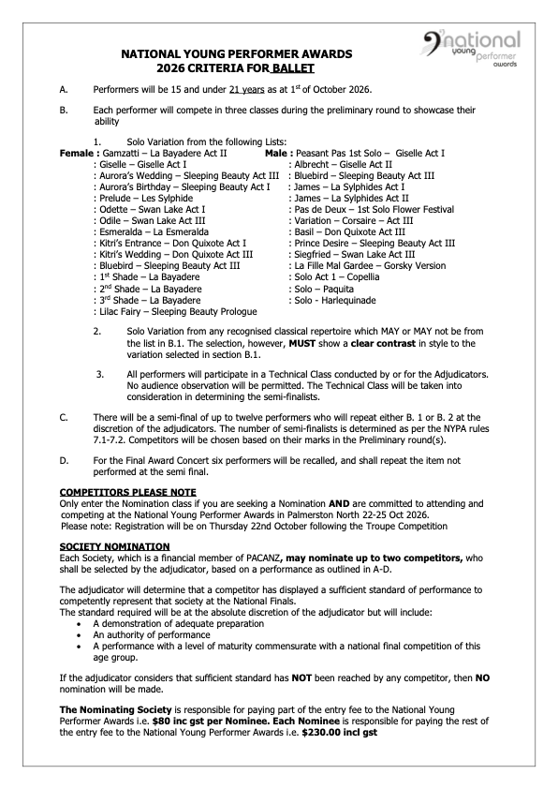

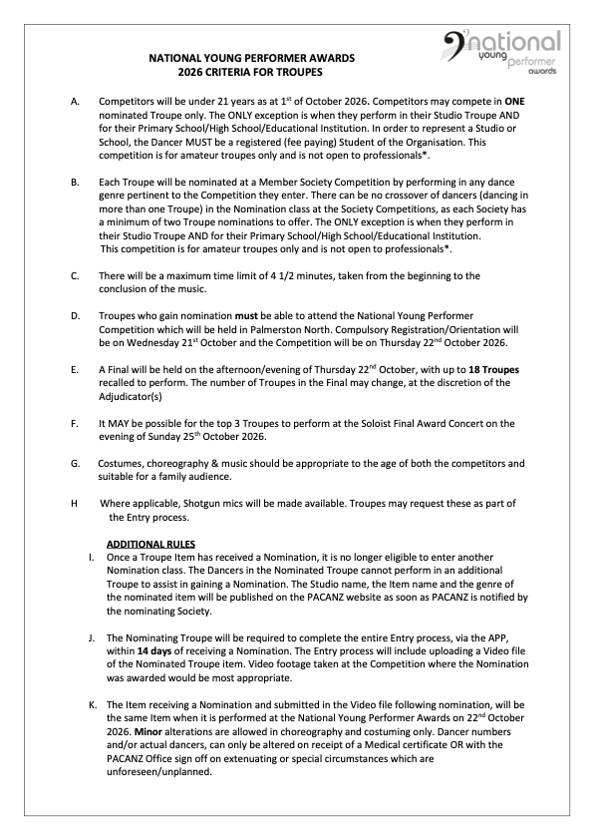

PNDA Committee

Patron : Deirdre Tarrant

President: Maryanne Mechen Vice President: Yvonne Hocken
Secretary: Lauren Francis Treasurer: Kathy Geange

Committee Members
Christine Booker, Dayle Campbell, Pam Fowler, Tracy Horman,
Michelle Robinson, Lisa Procter, Katrina Rose, Rosemary Sutherland-Smith

pndacompetitions@gmail.com
Website - PNDA.NZ

